**DAY 3 Session**

**1] Cloud?**

Types of cloud?

Advantages of cloud?

Why cloud?

**2] AWS: services**

Ec2 (laptop)

Connect to ec2

->Linux

->Windows

Public and private key->overview

SSH -> *Putty, Mobaxterm.*

**3] Datacentre (intro)**

*Example: Us Virginia Useast-1e.*

***HISTORY OF AWS:-***

2005 - 1) Storage as a service

2009 - 2) Big data -> EMR

2019 - 3) Quantum computing

4) Satellite as service

**ON Demand Scale UP/DOWN (costing)**

*Ec2 Types search it on Google*

**Linux:-**

Time*[cost (CPU*RAM) +cost (Hard disk)]

Small point: Cost doesn’t depend upon the cost of operating system but the resources used.

i.e.: 1 * Cost (t2 micro) + cost (8 GB)

1 * Cost (t2 medium) + cost (18 GB)

Total cost ->x (Pay as you go)

**Windows:-**

Time * cost (t2 micro) + cost (8 GB) + cost (OS)

**When Ec2 state is stopped:**

**Linux:-**

Time * cost (Hard disk) [cost required is Cheap as hell]

**Windows:-**

Time *[cost (hard disk) +cost (OS)] [Cost required will added as compared with Linux because of the OS]

**AWS pricing calculator:**

Just to find out the total estimate cost of using instances

<https://calculator.aws/#/>

**Cloud Firewall :-**

Rules

Inbound Rules(incoming)

Outbound Rules(Outgoing)

This is actually used which is known as ports ->

If an example port 22 in inbound traffic can only go through that port

Example port 80 in outbound traffic can only go through that port.

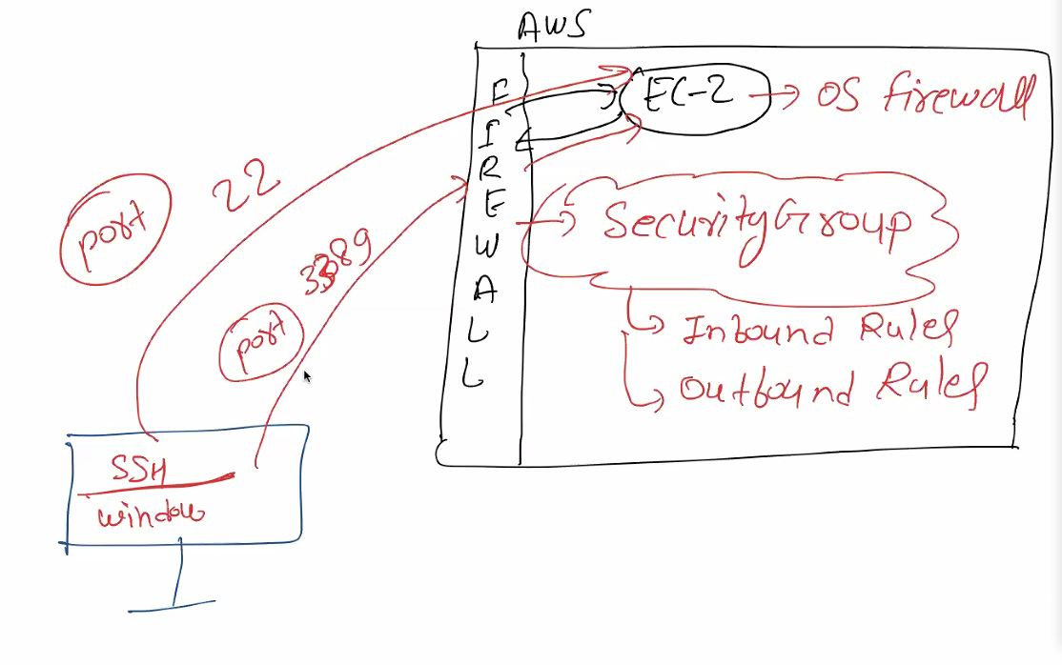

Working of Firewall

Go to your instance page on AWS.

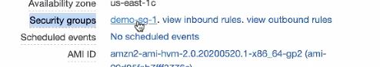

Click on that.

*You can edit your inbound rules and add port but don’t delete the default port present.*

*No limit on how much traffic goes and comes under inbound and outbound.*

**DATA centre:-**

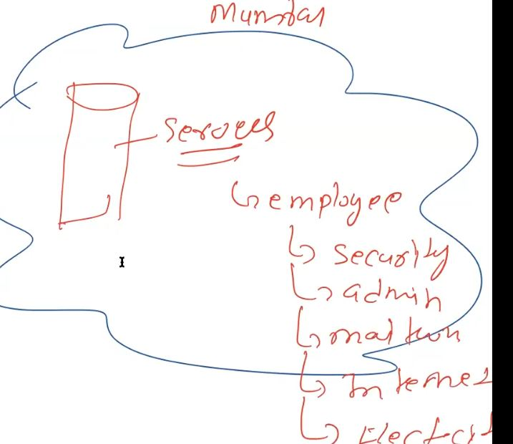

For example: Mumbai region datacentre

If any natural disaster occurs then all the host associated with data centres will be down

So for they created availability zones in various different regions of Mumbai.

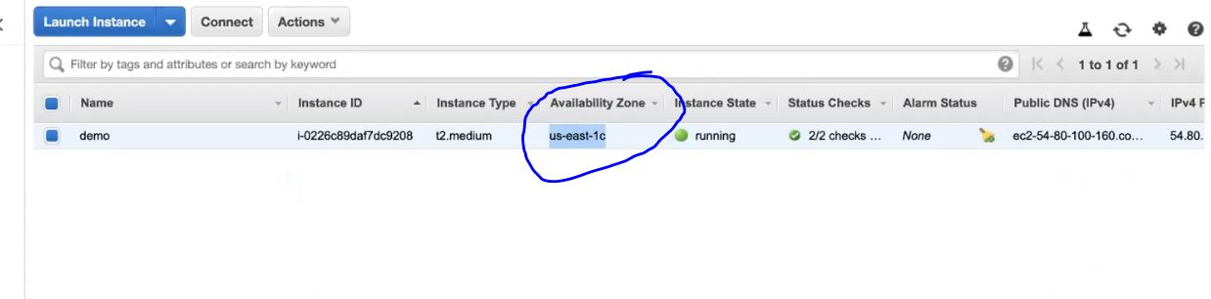

Here is the availability zone present in USA.

STORAGE :

In AWS storage there is a service named S3

For example it is similar to google drive

But S3 is at much larger scale than a mere google drive.

TO GO TO S3 SERVICE go through services and search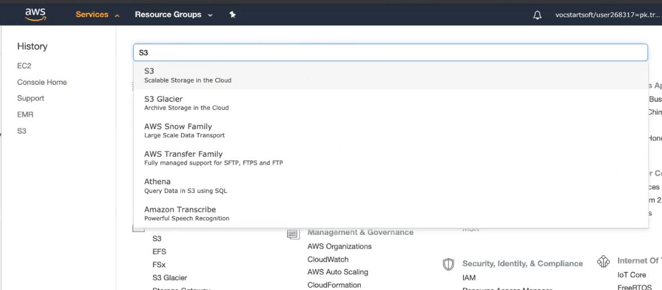

It will be giving an option of create bucket

Bucket means folder..

Bucket name should be unique across the AWS service.

You can upload and store data over there.

They charge you as per Gb and days.

This is also called as STORAGE engine.

And EC2 is called as COMPUTE engine.

**Buckets -> FOLDER**

**It is an object which is immutable.**

**Pricing of storage depends** 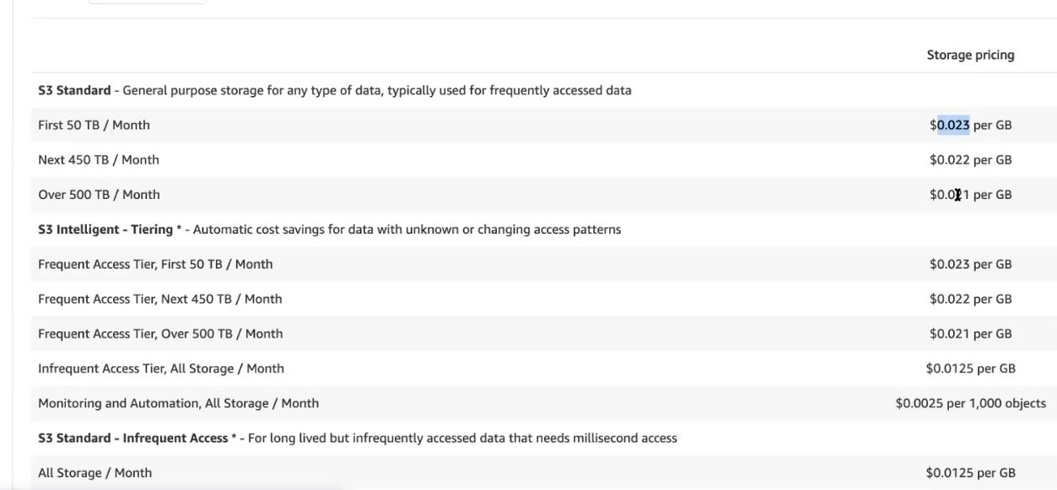

**Locally we can edit the files in the storage**

**But not on the server.**

***AWS reinvent themselves every year***

***They add new services and add existing enhancements.***